Software Requirements Specification
for
<Project>
Version 1.0 approved
Prepared by < Gerald Myrta, Erjon Doga, MarselaHoreshka, Megi Spahiu, Oksana Kadriu,>
<organization>
<date created>

Contents
1. Introduction 1
1.1 Purpose 1
1.2 Intended Audience and Reading Suggestions 1
1.3 Product Scope 1
1.4 References 1
1.5 Product Perspective 1
1.6 Product Functions 2
1.7 Operating Environment 2
1.8 Design and Implementation Constraints 2
1.9 User Documentation 3
2. External Interface Requirements 3
2.1 User Interfaces 3
2.2 Hardware Interfaces 3
2.3 Software Interfaces 3
3. System Features 3
3.1 Requirements 4
4. Diagrams 5
4.1 Use case diagram 5
4.2 Sequence Diagram 7
4.3 ER Diagram 7

Introduction

Purpose
The project's primary goal is to create an online library for an Albanian collage, that will shorten the time it takes for students to find and check out a specific book. This project aims to manage the functionality of the online library through the application, which will make the work of the employees and its users simpler and more manageable. Also, this application will make it possible for any information in university library to be found online in a way that is more efficient for every reader who wants to choose their favorite book without having to be in the physically present at the library.

Intended Audience and Reading Suggestions
This document is intended for both the stakeholders and project team including developers, project manager, business analyst and testers. It will contain an overall description of the system, users and other information. Requirements will be detailed and explained.

Product Scope
Our program will be used by staff of a library who will be guided by the admin, as well as customers who will be readers who will register their data in order to have access to the application. The software will do all of the tasks of a real library, but it will be online, allowing you to look for books from multiple sources, borrow them, and return them. Every action done by the customers will be managed by the administrator.

References
The information about how a library works was taken from the Internet, but mainly from physical libraries in the city.

Product Perspective
Online Library offers members to reduce the time of reserving various books owned by the university library. Users, students in this case, have the opportunity to make online orders through the application and receive at the moment of the search whether the book they want is free or not. After making the order, they must physically appear at the library with an identification tool to retrieve the ordered book. Potential users access all the books that happen to be in the library.

Online Library do a single functionality:
- Keeps connected with inventory (another ledger).
  - A book has a title, author and description.
  - Inventory also keeps track of the amount of stock/reverses for each book.

- Maintains records for multiple clients.
  - A customer can be a member or a non-member.
  - A customer for a username (each username is unique), password, email address, phone number and an email address.
  - Anyone can register to create a customer account.

- For every client who joins:
- Displays a list of books that are available.
- Allows people and managers to log in and out of the system.
- Offers the possibility of editing registered books.
- Allows adding and deleting books from the library.
- Allows the fulfillment of orders by identities.

Product Functions
- Provides users with simple and advanced search options based on such search criteria as: author name, book title
- Realizes a clear division of books into categories to facilitate search
- Allows users to create and manage their personal accounts
- Users can make online requests for various books
- Informs users about books being added or deleted from the library
- Offers the possibility of adding, deleting and updating existing books
- Provides general descriptions of each book

Operating Environment
The main communication interface of the program is the Internet. A user will be able to access and use the functionalities of the online Library only if the computer he is working on has a stable internet connection. The server-side components of the software system must operate within one of the operating systems environments. The client-side components of the software system must operate within common web browsers environments, like Google Chrome, Microsoft Internet Explorer.
.

Design and Implementation Constraints
The application will have no hardware limitations, software limitations, security limitations or parallel processing. The only limitation will be the provision of a stable connection to the Internet for the use of its functionalities.

- Design Constraints

As we have mentioned, the application does not contain hardware or software limitations, nor in design. The design is built using client-side languages ​​such as HTML and server-side languages ​​such as PHP, which are easily configurable. Care must be taken in the unified use of the coding used and preliminary tests should be made as to how our application will look in different browsers: opera, chrome, firefox, etc.

User Documentation

Regarding the methods and ways, we connect and communicate with each other, we can say that we are oriented towards informal approaches, interpersonal procedures including electronic communication. Group members will hold group meetings periodically. The group acts as a whole. Within the group, everyone contributes in their own way, while outside the group, responsibility is shared equally. Members will communicate with each other through e-mail or even facetime to communicate in real time. To make everyone's work accessible in real time, different platforms will be used, such as google docs or github.

Development model
The development model that we have choose to work with is Aigle Model. That’s because this strategy works well for projects with flexible timelines that have changing requirements. The Agile methodology enables the incorporation of feedback at each step of development, guaranteeing that the finished product satisfies the requirements of its users. It involves frequent collaboration between our group members.

External Interface Requirements

User Interfaces
Since the online library is being built specifically to help the students, its users will definitely be the students of this university. The application will have a simple and flexible interface that greatly facilitates the search process, for this reason users do not need to have good technical knowledge except for basic knowledge to navigate the Internet. It will be aimed at creating a simple self-descriptive interface that will be comfortable and easily perceptible by users.

Hardware Interfaces
No direct hardware interfaces, as the primary interaction occurs through web browsers on user devices.

Software Interfaces
There are no connections between this product and other specific components. Exists only the connection with database.

System Features

Requirements
In this section, all the functionalities of the software product will be described in detail based on the importance and performance level of each one. Each required function will be analysed and presented through:
• Descriptions
• Criticism
• Technical issues

- Simple and advanced search capabilities

In this section the user can perform two types of searches. First, we have the simple search where the user can search for the title of the book, or its author, and all the books in our library will be displayed. Second I can perform an advanced search. In this type of search there will be several text boxes where the user will click or mark taking into account the requirements he has. So I can search for example for all the books of a certain category that have a price above a certain value, or that were written by a certain author
- General descriptions of books

The online library will contain all the books that are in the university’s physical library. After users complete their online order, they will be able to pick up the book at the physical library. The books will be in line with the existing branches of the university. So there will be books on economics, computer science, mathematics, statistics, etc. We have divided the latter into six major categories: Management, Economics, Marketing, IT, Accounting, Finance. Each of these categories has corresponding subcategories. Each book has attributes such as: title, author, a brief description of the book, and price.

- Creating and managing user accounts

Each user, student in this case will have his personal account so that he can use the functionalities of the application. The user creates the account the moment he tries to log in to the application. To register, he must fill out the form with data such as: first name, last name, place of birth, registration date, expiration date, email, phone number.

- Online release of physical book requests

After finding the desired book, the user can see the number of available copies of the book. If the number of available copies is different from zero, then he has the option to reserve the book by clicking the reserve button and physically appear near the library to retrieve the book. If the number of copies is zero, that is, the books are all reserved, then he clicks the borrow button and waits until the book becomes available.

- Dividing books into different categories

We have divided the books into six major categories based on the constituent branches of the university such as: Management, Economics, Marketing, IT, Accounting, Finance. Each of these categories has corresponding subcategories.

- Adding and deleting different books

The administrator has the right to delete or add different books. They can add new books as well as remove damaged books.

- Performance Requirements

In order to achieve its main purpose, the application supports simultaneous requests by processing them in parallel. The user does not have to wait more than 10 seconds to get the result of his search. Its flexible interface, with clear and distinct divisions, increases performance by facilitating navigation and reducing search time.

- Database logical requirements

Our database will consist of 4 big entities: Category, User, Book, Authors. In addition to these, there will be another table which will keep track of which user received which book.

Diagrams

Use case diagram
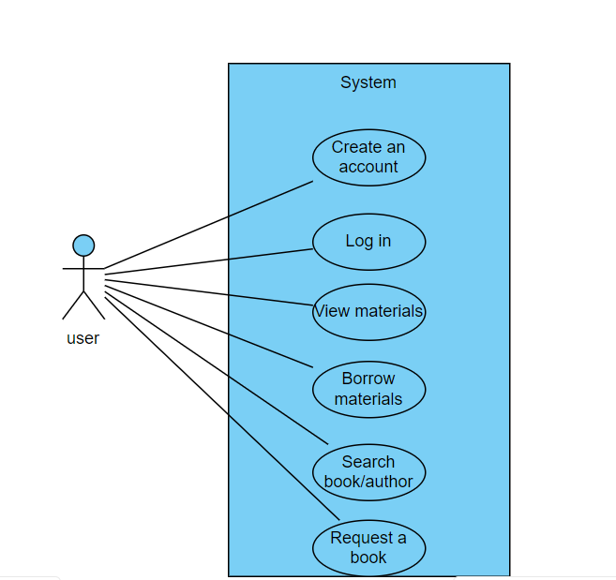

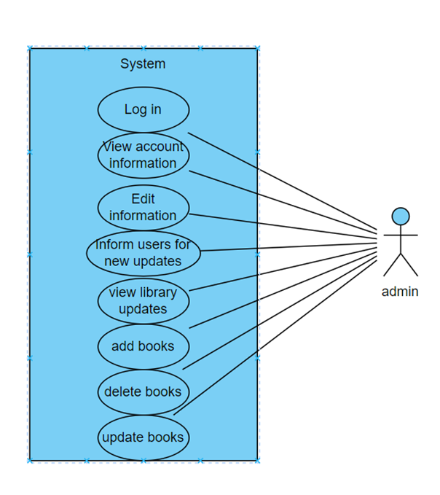

Sequence Diagram
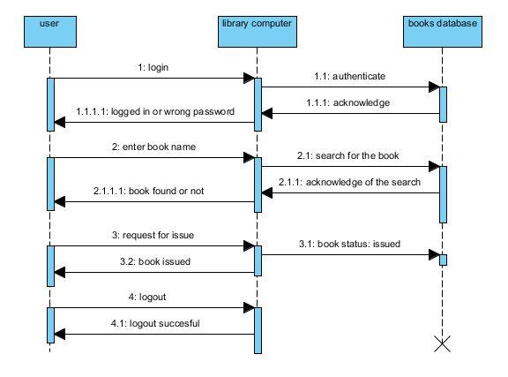

ER Diagram

